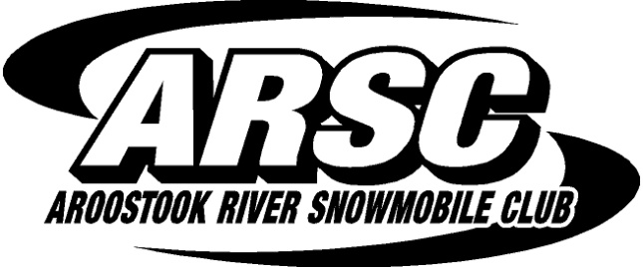

www.aroostookriversc.com

SPONSORSHIP BOARD
Business Name _______________________________ ________________________________
Contact Name _______________________________ ________________________________
Mailing Address _______________________________ ________________________________
City, State, ZIP ________________________________________________________________
E-mail Address ________________________________________________________________
Phone _______________________________________________________________________

Renewing from previous year: Yes (no graphic need) _____ No _____

- 12x12 ($100) (5 years for $400) $__________
- 12x24 ($200) (5 years for $800) $__________
- 24x24 ($400) (5 years for $1600) $__________
- Donated Material or Time $__________
  - Donation of _________________________________________
  - Approved sign _______________________________________
  - Approved by representative____________________________
- Total Due $__________
Please return this form and graphic to:

An ARSC representative

Or

info@aroostookriversc.com

or

Aroostook River Snowmobile Club
PO Box 108
Presque Isle, ME 04769

